Craig Brown

Mobile UX Review: Youtube Mobile

One of the first things a user might notice about youtube mobile is that there is no concept of a home screen. On the mobile app, the home page is replaced by the popular videos page. This is not immediately obvious, as the popular videos page can easily be mistaken for the home page as it is the first destination upon opening the app, and it also resembles the full website's homepage in that popular videos are prominently featured even on the website's homepage.
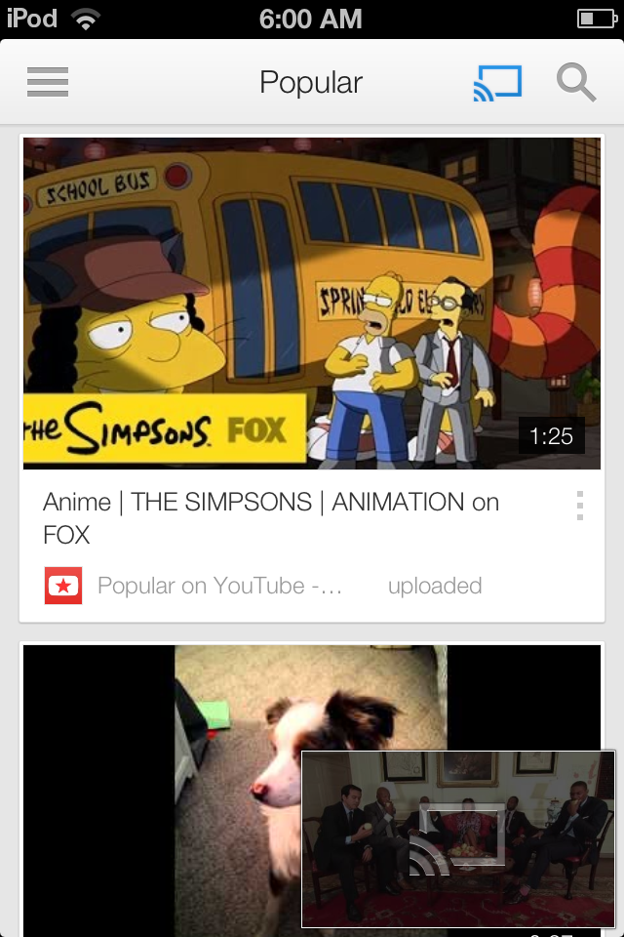
Another cool feature is persistence of currently playing or recently played videos in the bottom right corner of the screen. The image above demonstrates that a user can browse through different pages of the app, while either being able to still view and quickly jump back to current video. This can be particularly useful when used in conjunction with Google's Chrome Cast, as a video is able to be persistently cast to a device, such as a TV, while the user can explore for new videos on the mobile device itself. The Cast icon also appears on the video thumbnail in the lower right showing that the current video is also being cast to a device. Ultimately I found that this feature can also be viewed for its negative qualities, as the current video thumbnail also becomes the most recently played thumbnail. Having the most recently played thumbnail was particularly troubling when trying to scroll through videos on the popular page quickly, as I found I would sometimes accidentally swipe the video thumbnail and jump to video page instead. It wasn't until the app cleverly taught me that I could swipe left on the icon to dismiss it that I was able to stop the video thumbnail from following me around the app, but until this lesson was triggered, it was a bit troubling.

Another note on navigation is that there is no dedicated “back” functionality. In fact I spent a significant amount of time trying to figure out how to go back to no avail. Although the idea of going back is pretty essential on the web application, it is missing from the mobile app. This can make it easy to get lost within the application as a whole. The alternative I ended up learning, was to use the sidebar menu in order to navigate the application. In fact, it was only this menu that helped me realize that I wasn't actually trying to go “back” to the homepage at all, but that I was trying to navigate back to the popular videos page.
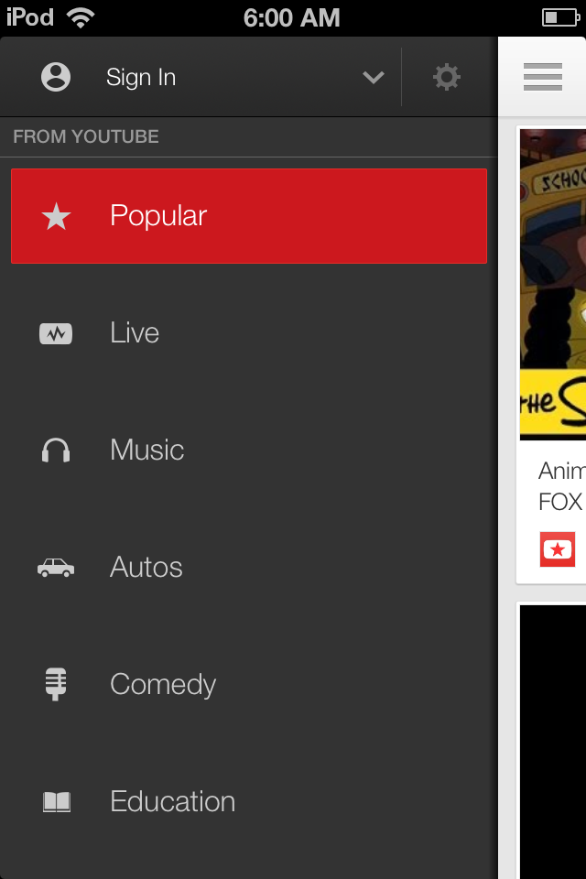
One feature which appears to be a bit wasteful is the preview feature. That is, when a user taps on a video thumbnail from one of the filter pages like the popular videos page, instead of being immediately jumped to the video page, a popup menu comes up giving the user a description of the video and the option to either play the video or add it to the queue.
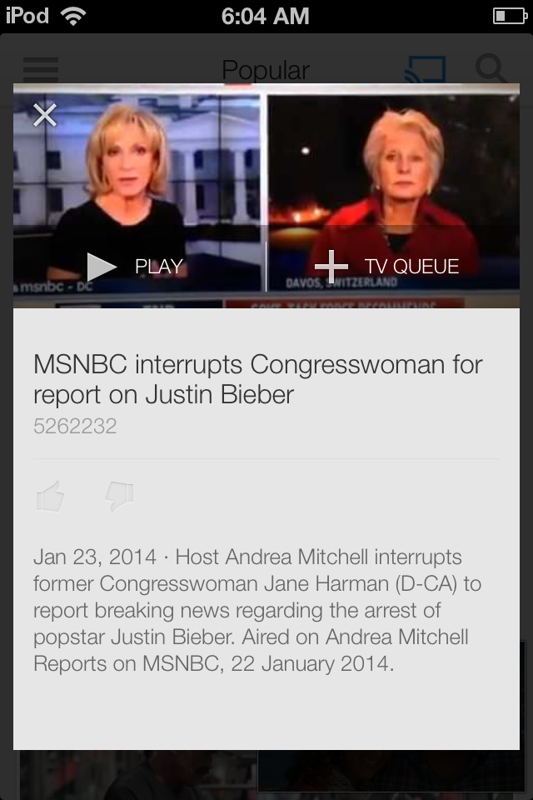
Neither of these options can't be found on the video page itself, so this popup feels like an unnecessary step. A more efficient alternative may have been to simply add icons over the thumbnail of the video on the filter pages for “play” and “add to queue”, while tapping on the general area of the thumbnail itself would immediately jump the user to the video page.

Another issue arises with the “minimize to thumbnail” icon (a downward pointing arrow) used to minimize the current video and revert users to the previous page. When opening the sidebar menu, the same icon is used next to the sign in link. I initially expected similar functionality to the minimize icon, but instead found that this simply jumped me to a new page entirely to sign into google. There is a memorability conflict here by using the same icon for different purposes.

I also took note of the pull to refresh functionality on the app. While this works fine on the sidebar menu, I noticed that on the video pages, trying here there wasn't enough screen space on the mobile device to execute a pull to refresh with one finger. Instead I had to take a lot of time to perfect a two finger technique to perform a double pull to refresh on the limited space under the video itself. A reconsideration for the space limitations would be useful here, perhaps decreasing the distance needed to pull to refresh on video pages.

The primary task analysis I performed on the app was casting a video to a TV via built in chromecast functionality. I was most pleased to realize that immediately after downloading the youtube app to my ipod touch, casting functionality to my existing chrome cast was automatically enabled! There was no need to download a separate chrome cast application, and no need to set up my chrome cast device on my ipod touch. Presumably the fact that I was already connected to the same WIFI network as the existing chromecast device lead it to automatically sense and enable the device.

Casting itself is easy and intuitive. The cast icon not only appears non-intrusively at the top right corner of the video, but it is also available on the top right of the filter pages, giving the user the option to initialize the casting connection either before or after selecting a video they want to watch.
